List of responsibilities to Navigate.

**Gold Business:**



**Aluminum Business:**

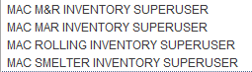

**Industrial Minerals:**



**Phosphate Business:**





**Corporate Business:**



**========Example on retrieving Pending Transaction for Inventory Org:===========**

**Inventory Responsibilities:**

**1.OPEN-> INVENTORY ACCOUNTING PERIODS**

**🡪SELECT SPECIFIC ORG**

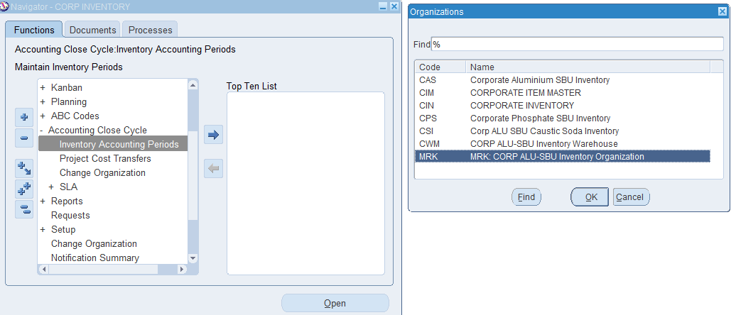

**2.Browse on Latest period which is Open.**

**Here its JULY’20, Open PENDING -radio button.**

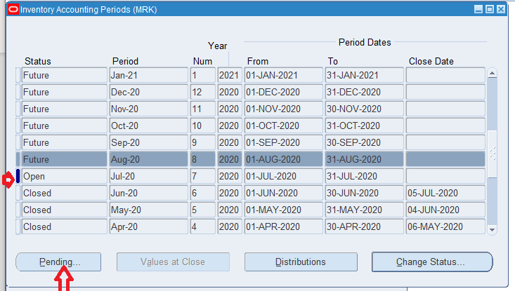

**3.Noting down all pending transactions against each bucket.**

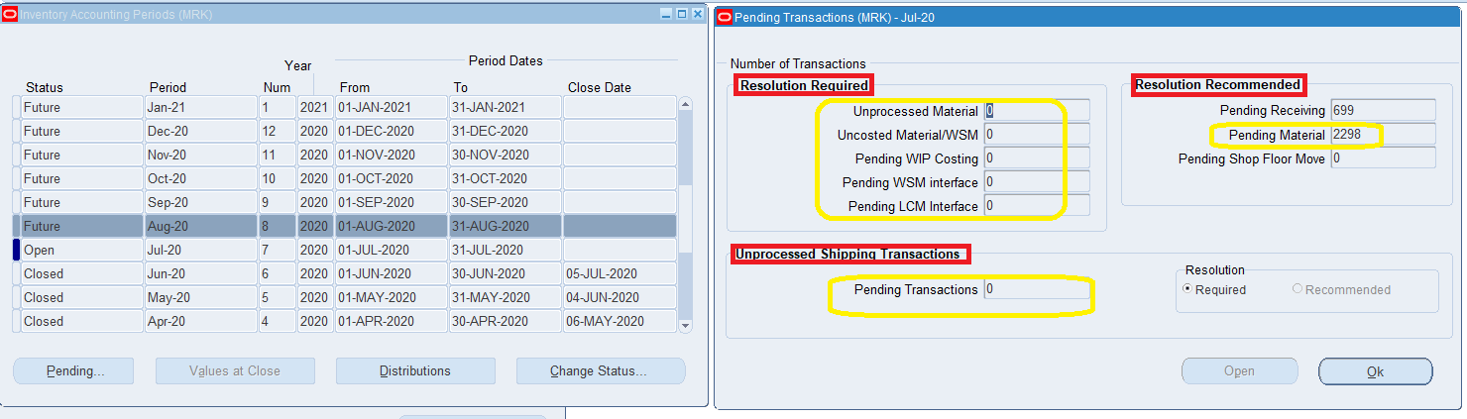

**Above steps must be captured for all Inventory orgs across Operating units.**